**SAP Projects**

**These are the types of Projects in SAP:**

* + **Implementation**
  + **Support**
  + **Upgrade**
  + **Rollout**

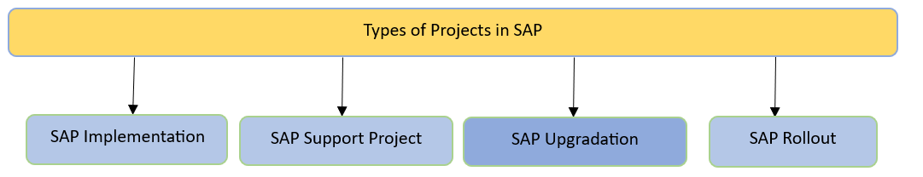

**Implementation:**  
  
SAP Implementation is the whole of processes that defines a complete method to implement SAP software in an organization.

* + Customer wants migrate data from Legacy system to SAP system.

**Support:**  
Customer has already installed SAP and wants to give the work of maintaining those systems.

* + After a go live, the application needs a support to resolve the issues/tickets raised by the end users when doing the day-to-day activities.

**Upgrade:**  
Upgrading the software with a superior version which has got more advantages when compared to the earlier version.

* + Already sap implemented with older version, and they are upgrading to newer version. Like 4.7E to ECC6.0

**Rollout:**  
Customer has upgraded his version and wants to rollout country specific changes.  
SAP implemented in one plant some time back, new plant started. So, the customer want SAP implemented in new plant also.

* + Roll out is copying same configuration to other Country/plant.

**Implementation**

SAP implementation refers to the collective practices and workflows intended to create, design, and tune an SAP landscape. Each SAP implementation is unique. The project is undertaken to reach high-level goals like better communication and an increase in return on information. Therefore, SAP implementation projects require extensive planning and execution with a solid method.  
  
**Below mentioned comes under Implementation process:**

* 1. ASAP Methodology
  2. Solution Manager

**ASAP Methodology**

**There are mainly 5 steps involved in this process:**

* 1. Project preparation
  2. Business Blueprint
  3. Realization
  4. Final preparation
  5. Go-Live & Support

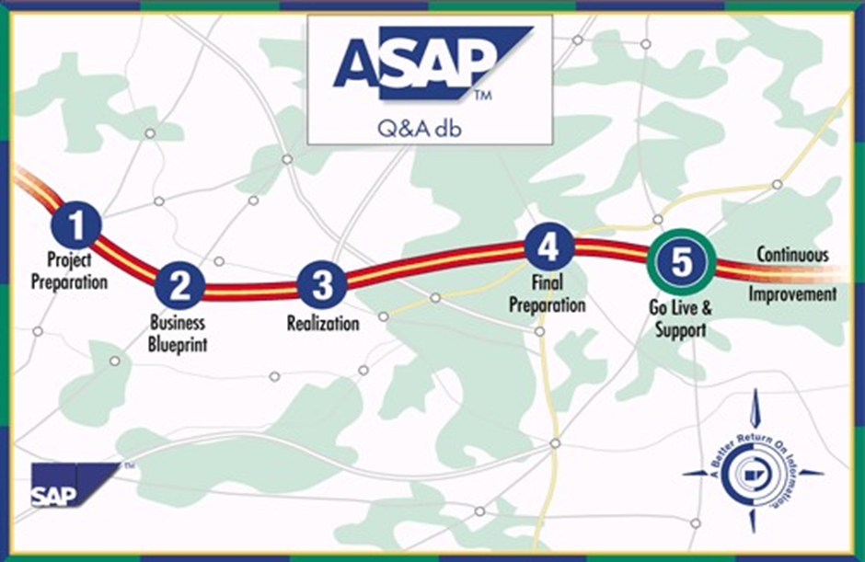

**1. Project Preparation:**During this phase the team goes through initial planning and preparation for SAP project.

* + Modules, Team size, Duration, Budget  etc.,

**2. Business Blueprint:**

In this phase team will create the business blueprint, which is detailed documentation of results gathered during requirement workshops.

* + System Landscape, Implementation Date, Completed and signed off Process Design etc.,

**3. Realization:**

In this phase you will implement all the business and process requirements based on Business Blueprint.

* + Configuration/Customization, Developments, Integration Test, User Acceptance etc.,

**4. Final preparation:**

In this phase testing is completed. Team will complete testing to finalize your readiness to go live. Serves you to resolve all critical open issues, upon successful completion of this phase.

* + Data Converted, Unit test, Cut-Over Plan, End-Users Trained etc.,

**5. Go-Live & Support:**

In this phase all development objects move from a project-oriented, preproduction environment to live production operation.  
  
**The list of pros and cons of the SAP implementation project is:**  
**Pros**

* + **Streamline Workflows:** The SAP implementation project will allow you to handle multiple modules in one centralized location.
  + **Better Financial Planning:**Due availability of forecasting and reporting the data SAP project aids in financial planning and provides real-time data to make the best decision.
  + **Improvement in data security and accessibility:**A common control system for the organization allows the company to improve its data security and accessibility standards.

**Cons**

* + **Slow implementation:** It takes a lot of time to adapt to SAP implementation projects.
  + **Expensive:** a new SAP implementation project will cost you thousands, especially if your hardware system is outdated.

**There are two common methods used for SAP implementations:**

* + Big Bang Implementation
  + Phased Project

**Big Bang Implementation:**

Under Big Bang implementation all your computer systems will start using the project on the same day. It is just like turning off your old working system and immediately using the new one.  
Generally, organizations select this implementation approach because it is a faster and cheaper option. In this approach, detailed and end-to-end testing along with data validation can aid you to identify problems and bugs if any but will never help you to get the idea of the problem in a single area.  
  
**Some common pros and cons of Big Bang implementation are:**  
**Pros**

* + **Quick to implement:**You can implement the new system in a single day in your entire organization using this approach.
  + **Uniformity:**Big Bang implementation allows the usage of a single system in the entire company.
  + **Cheaper:**As the entire company is using a single system it involves fewer funds.
  + **More focused training:** Under this system, the training is offered with more focus as no one can identify the issues of a single area.

**Cons**

* + **Difficult testing:** Full testing is quite difficult under this approach before going live.
  + **Wider scope of issues:**Due to the implementation of a new system in the entire organization the scope of potential system issues increases.

**Phased Project:**

Under this approach, you will roll out the software in a sequence by introducing the new software piece by piece. The phased project does not have one big go-live date, but it has numerous small go-live dates. Thus, offering your system and staff more time to adapt to the changes.  
  
**Some common pros and cons of the phased project are:**  
**Pros**

* + **Better Adjustment:**Due to piece-by-piece SAP implementation of the entire system everyone gets enough time to properly adjust and adapt to the new system.
  + **Comprehensive Testing:**More comprehensive incremental testing is possible under this approach.
  + **Easy to fix smaller problems:** Phased SAP implementation allows you to find out the smaller bugs and issues in a single area which allows the technical team to fix them quickly and with the utmost ease.

**Cons**

* + **Costly:**The longer timelines result in higher implementation and consulting costs. Sometimes you even need to spend some amount on the development of interface tools. Thus, making it an expensive option.
  + **Delay in ROI:** Return on investment is delayed due to the last time gap between this start and the final date of implementation.

**Development Life Cycle (Functional and Technical)**

* + Client business Process
  + Requirements Gathering GAP Analysis
  + Master data creation
  + Business documents
  + Functional specifications Technical specifications
  + Configuration
  + Customization
  + Cutover activities

**Testing**

* + Unit testing
  + Scenario testing
  + Integration testing
  + User Acceptance testing (UAT)

**Weekly Status meetings**

* + Kick off meetings
  + Escalations

**SAP Solution Manager**

SAP Solution Manager (SolMan) is a module of SAP that provides functionalities like integrated content, methodologies, tools etc. to implement, operate, monitor and support an enterprise’s SAP solution. SAP solution manager manages the SAP and Non-SAP solutions in the IT landscapes of an organization. It supports the underlying IT infrastructure and business processes. It is a powerful tool for SAP Basis administrators.

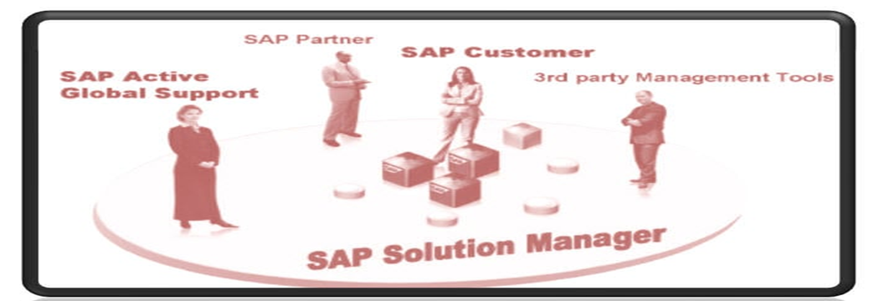

**SAP Solution Overview:**

**SAP solution manager provides you the tool, content, and gateway to create, manage, operate and monitor your solutions over time.**

**Tools**

* + Application/Technology Management and Maintenance
  + Documentation
  + Implementation
  + Training
  + Provision Testing
  + Support and Maintenance
  + Monitoring and Optimization
  + Change Control
  + Problem Management

**Content**

* + Methoden
  + Roadmaps
  + Services
  + Best Practices

**Gateway to SAP**

* + SAP Active Global Support
  + SAP Development
  + Service Delivery Platform

**Tools:** SAP solution manager gives you central access to the tools which you need to implement your business solution. For example, Roadmap, Project administration, Business Blueprint etc.  
**Content:** You create a solution with the SAP solution manager, which serves as a template for your implementation project. The solution contains a package of reusable preconfigured content (documentation, pre-configuration and test cases). Content is a collection of information of business process and stored in various formats. And a content manager structure and manages this information.  
**Gateway to SAP:** You manage and monitor systems and business processes in your solution landscape in operational processing. You set up and run your own solution support.

* + SAP solution manager accelerates the preparation and execution of tests. It will provide you with a central point of access to your overall system landscape.

**Process Flow:**

* 1. The roadmaps contain all the information about project phases and implementation of the project.
  2. You start to use the SAP solution manager towards the end of the evaluation phase. Define your project in the SAP solution manager.
  3. Set the project scope in the project definition.
  4. Define the system landscape required for the implementation of business process.
  5. It defines a Business Blueprint by documenting the organizational unit, master data, and business scenarios etc, required for the implementation of a business process.
  6. Configure business scenarios in the development system.
  7. Check the test cases delivered and assign further test cases to processes and process steps.
  8. Check the consistency of the customizing of your business processes.
  9. Organize test and can reuse the test cases selected during configuration.

**Benefits of SAP Solution Manager:**

* 1. **Lowering Cost:** SAP Solution Manager helps you make the most of SAP’s support services-significantly lowering your total cost of ownership.
  2. **Automated Alerts:** There is no need to search out system error manually; the team will be instantly notified of any issues or errors automatically.
  3. **Improved patch and upgrade management:** Just one system will manage cross-system patch updates and synchronization.
  4. **Automated configuration tracking:** A fully maintained knowledge repository enables users to keep track of all configuration changes.
  5. **Centralized Management:** It acts as a central point of control for the entire solution landscape and centralized management for the multi-component projects.
  6. **Reduces Administration Effort:** It does real time monitoring of systems, interfaces and business process which reduces administration effort.
  7. **Easy Integration:** Integrates with IT landscapes that include both SAP and non-SAP applications.
  8. **Faster ROI**: It accelerates implementation and continuous improvement. Availability of implementation roadmaps, best practice documents and SAP solution management services speed learning and accelerate project.

**SAP Support Project**

SAP support project is also known as an issue tracking system because it handles tickets. Under this project, the errors and bugs from the end-users are forwarded to the support team to categorize them into the level of severity i.e., low, medium, or high.  
  
The pros and cons of this project are similar to that of SAP implementation projects.  
  
However, no one can deny that the SAP support project is the foundation for improving the functionality and increasing SAP knowledge to the community of users. Show respective of your situation try to optimize SAP and surrounding business processes for boosting user satisfaction by implementing SAP support project.

**1. Ticketing tools:**

Ticket tool means which software we are using for handling the ticket.

* + RADIX, REMEDY, TRACKIT

**2. SLA (Service Level Agreement)**

**Support tickets:**  
Depending upon the severity of the issue the ticket creator decides the priority of the ticket. It will be given severity.  
**There are following severities:**

* + Critical, High, Medium, Low
  + It may vary from company to company.

**Critical:** Tickets should be solved in 8 hours.  
**High:** Ticket should be solved in 16 hours  
**Medium:** Ticket should be solved in 5 working days.  
**Low:** Ticket should be solved in 10 working days.

**Project Team**

**Roles & Responsibilities:**

* + Consultant
  + Team Lead
  + Onsite & Offshore
  + Project lead
  + Project manager

**Functional Consultant**

**Roles & Responsibilities:**

* + How to connect Client
  + Systems/network

**Upgrade Project**

It is a periodic project that companies implement to upgrade their system to the latest version. Under this project, the goal of the company is to technically upgrade and to cover the evolution of the SAP technical enhancement package.  
  
For instance, if a company wishes to upgrade to SAP ERP 6.0, it needs to implement this project. As a company needs to change its operating system hardware and database platform. Plus, they need to perform a Unicode conversion.  
  
This up-gradation project allows the companies to select from the two strategies that are resource minimize strategy and downtime minimize strategy. The technical team needs to select this strategy for this project after a deep evaluation of technical considerations and economic needs.  
  
**Resource Minimize Strategy:** This is the preferred strategy if the business has hardware resource constraints but can afford longer downtime.

* + Lower demand on system resources
  + Increased production downtime

**Downtime Minimize Strategy:**This is the preferred strategy if the business cannot afford longer downtimes and if sufficient hardware resources are available.

* + Shorter production downtime
  + Higher demand on system resources

Most of the Companies use the Downtime Minimize Strategy.  
**Steps involved under the SAP up-gradation project are:**

* + System Preparation - (BASIS Team)
  + SPDD phase - (Functional and Technical)
  + Upgradation of the system - (BASIS Team)
  + SPAU phase - (Functional and Technical)
  + Testing - (Functional and Technical)
  + Z programs - (Functional Team)
  + Post-program upgrade activities – Some activities have to be executed manually in each system after upgrade since they cannot be included in a Transport Request.

**Pros**

* + **Benefits from Innovations:** An up-gradation project allows your company to enjoy the benefits of innovations and upgrades of SAP.

**Cons**

* + **Critical Testing:**The SAP up-gradation project requires deep testing to identify critical issues which can lead to the failure of the entire system, which is time-consuming and an expensive process.

**RollOut**

Roll out in simple terms is nothing but reuse of the implementation process in the new location and change the settings according to location of the Implementation.

* + In Roll outs you don’t need to do everything from scratch.

For example, for one client if the company develops a global template solution and go-live with a few countries. Subsequently, it adds local processes in the solution of another site and again went live is termed as an SAP roll-out project.  
  
For this project, you need to do some fundamental settings as per the location of the implementation. There is no need to do the entire work from scratch. All you have to do is to work on logos, company code, and printouts. Also, change the people integration and Management as per the company’s requirements.  
  
However, while implementing the SAP rollout project you need to pay special attention to geographical concentrations.  
  
**Pros and cons of SAP roll-out projects are:**  
  
**Pros**

* + **Speedy:** It increases the speed of the new implementation project and helps you to meet the timelines or deadlines.
  + **Controlled budget:**Under SAP Roll-out projects don't need everything new, so helping you to implement the new system within the control budget.

**Cons**

* + **Existence of old systems:** The only disadvantage of this project is that you still need to use some software from your current system.

**System Landscape**

**Standard System Landscape in SAP is:**

* + Development System
  + Quality System
  + Production System

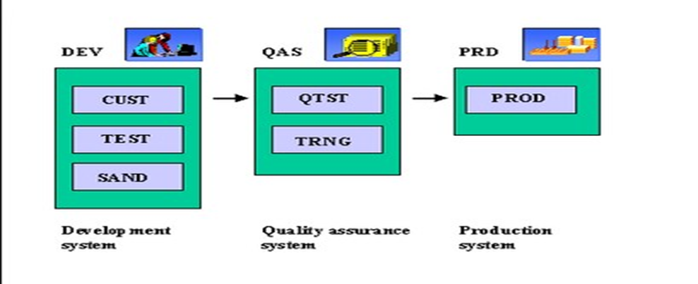

**Development System:**

* + In the development system the consultants do the customization as per the company’s requirement.  We have two types of configuring systems in the Development system.

|  |  |
| --- | --- |
| **Sandbox System** | **Golden System** |
| R&D System, Implementation project initial stage we will have in sandbox system. | The Development system is where all the configuration & development work takes place. |

**Quality System:**In the Quality system where the core team members and other members test the customization.

* + The Quality assurance system is where all the final testing is conducted before moving the object to production system.

**Production System:**In the Production System where the live data of the company is recorded.

* + The production system is where all the daily business activities occur, all the end users will use this system.

A request will flow from Dev -> Qual -> Prod and not backwards.

|  |  |  |
| --- | --- | --- |
| **Sandbox server** | **Development Server** | **Production Server** |
| In the initial stages of any implementation project, you are given a sandbox server where you do all the configuration/customization as per the company’s business process. | Once the BBP gets signed off, the configuration is done in the development server and saved in workbench requests, to be transported to Production server. | This is the last/ most refined client where the user will work after project GO LIVE. Any changes/ new development is done is development client and the request is transported to production. |

**Transport System**

* + **Transport Request:**A transport request collects development objects and categories for export to your local computer or to an SAP transport system.
  + **Request Handling:**A handler, or request handler, is a program that receives a client request for access to the service and translates the request into a form that the service can understand.
  + **Task:**A task is a request for a human to perform an action.

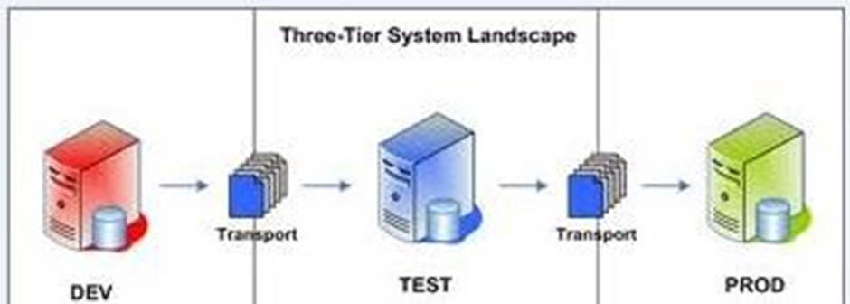

**Transport Request:**  
Transport Request is a collection of changes that are made in the development system. It also records the information regarding the type of change, the purpose of transport, request category and the target system. It is also known as Change Requests.

* + Each TR contains one or more change jobs. Tasks are stored inside a TR, just like multiple files are stored in some folder. TR can be released only once all the tasks inside a TR are released or deleted.

If we want to upload the data through **Transport Request** from one Landscape to another Landscape first, we have to release the Transpose Request. In Releasing the Transport Request first, we need to release the Customizing task.  
Enter the Transaction Code SE01 in the Command field.  
Click on the Display

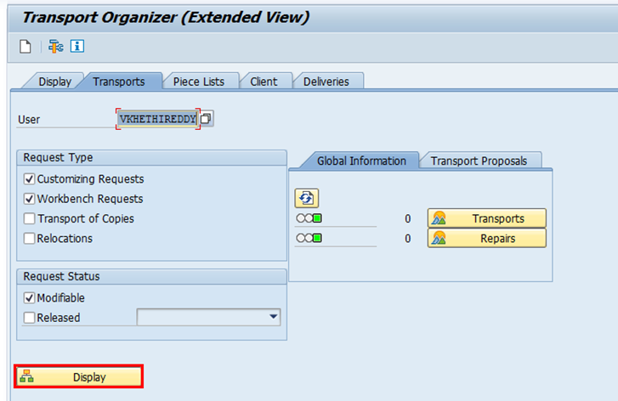Select the Customizing task and click on the Release Directly tab as shown to release the Task. Later then select the Main TR and click on the same tab to release Tab.

* + Without Releasing the customizing task, we can’t release the TR.

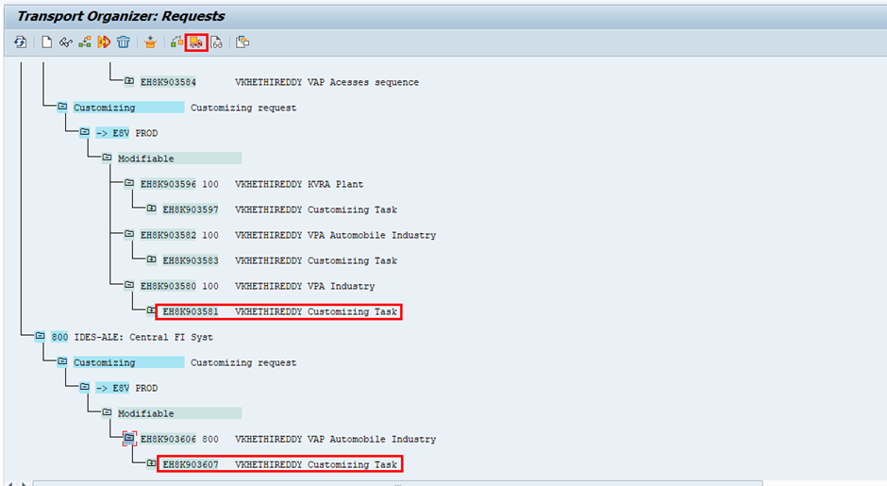Once Completion of Transport request (TR) Release, the system won’t display that Transport Request.  
If you want to transfer the data from Development Server to Quality System (Testing Server)                    

* + We can release the Transport Request (TR) first and send it to the Basis Team in sequence.
  + BASIS Team will upload/transfer the data by using Transaction code STMS.

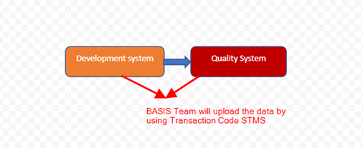

**If you are Uploading/Transferring data from one client to another client under the same landscape.**

* + No need to release the Transport requests.
  + We can transfer the data by using the Transaction code

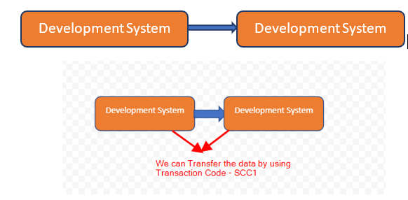Enter the Client Number, TR Number and select the checkbox Include the tasks in request and click on Start Immediately tab.

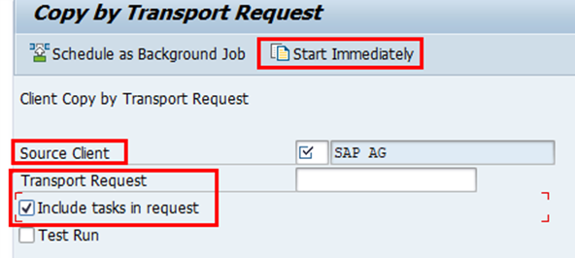

In Transport Request we have two types of Requests:  
           1. Workbench Request  
           2. Customize Request

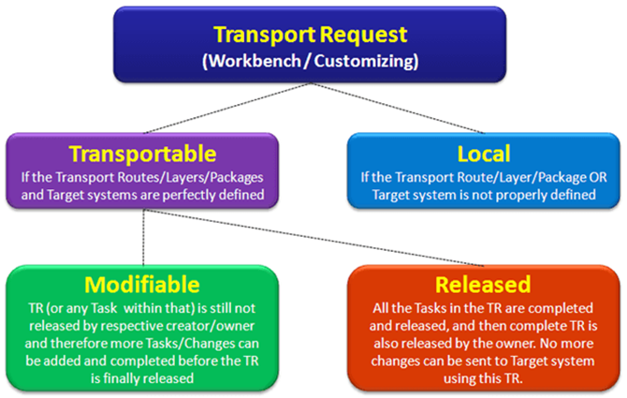

**Workbench Request:**  
Workbench Request contains repository objects and also ‘cross-client' customizing objects. These requests are responsible for making changes in the ABAP workbench objects.  
**Customizing Request:**  
Customizing request contains objects that belong to ‘client-specific' customizing. As per client settings, these requests are automatically recorded as per when users perform customizing settings, and a target system is automatically assigned as per the transport layer (if defined).